**Project On**

**Banking Management System Object Oriented Programming Lab**



**SUBMITTED BY: SUBMITTED TO:**

Komal Sharma (2004614) Prof. Manjot Kaur

D2CSB1 (CSE Department)

**GURU NANAK DEV ENGINEERING COLLEGE, LUDHIANA**

## WELCOME TO ABC BANK

*Yours dreams our responsibility*

|  |  |  |  |
| --- | --- | --- | --- |
| **S.No.** | **List of content** | **Page no** | **Signature** |
| 01 | Acknowledgment | 04 |  |
| O2 | Introduction | 05 |  |
| 03 | Description | 06 |  |
| 04 | Source Code of the Project | 07 - 13 |  |
| 05 | Outputs of the program | 13-16 |  |

**ACKNOWLEDGEMENT**

I am extremely grateful to Prof. Harjot Kaur (Department of information technology) for her able guidance and useful suggestions, which helped me in completing the project work, in time. A project is a bridge between theoretical and practical learning and with this thinking I worked on the project and made it successful due to timely support and efforts of all who helped me.

Once again, I would like to thank my classmates and my friends also for their encouragement and help in designing and making my project creative. I am in debt of all these. Only because of them I was able to create my project and make it good and enjoyable experience.

Amarjeet (2004887)

Harsh (2004924) D2ITA

**INTRODUCTION**

# Object Oriented Programming in C++

Object Oriented programming is a programming style that is associated with the concept of Class, Objects and various other concepts revolving around these two, like [Inheritance](https://www.studytonight.com/cpp/overview-of-inheritance.php), [Polymorphism](https://www.studytonight.com/cpp/function-overriding.php), Abstraction, Encapsulation etc. C++ is a general- purpose programming language that was developed as an enhancement of the C language to include object-oriented paradigm. It is an imperative and a compiled language.

Features of OOP

* [**Class**](https://www.edureka.co/blog/object-oriented-programming-in-cpp/#Classes): A class is a user-defined blueprint or prototype from which objects are created. It represents the set of properties or methods that are common to all objects of one type.
* [**Object**](https://www.edureka.co/blog/object-oriented-programming-in-cpp/#Objects): It is a basic unit of Object-Oriented Programming and represents the real-life entities. A C++ program creates many objects which interact by invoking methods.
* [**Polymorphism**](https://www.edureka.co/blog/object-oriented-programming-in-cpp/#Polymorphism): Polymorphism refers to the ability of OOPs programming languages todifferentiate between entities with the same name efficiently.
* [**Inheritance**](https://www.edureka.co/blog/object-oriented-programming-in-cpp/#Inheritance): Inheritance is the mechanism in which one class is allowed to inherit the features (fields and methods) of another class.
* [**Encapsulation**](https://www.edureka.co/blog/object-oriented-programming-in-cpp/#Encapsulation): Encapsulation is defined as the wrapping up of data under a single unit. It is the mechanism that binds together code and the data it manipulates.
* [**Abstraction**](https://www.edureka.co/blog/object-oriented-programming-in-cpp/#Abstraction): Data Abstraction is the property by virtue of which only the essential details are displayed to the user. The trivial or the non-essentials units are not displayed to the user.

Header files

A header file is a file with a extension .h which contains function declarations and macro functions to be shared between several source files. There exists many header files for cpp like iostream, string, fstream etc. but the header files used in the project are iostream and fstream. Iostream is a header file that is used for provided standard input and output functions like cin, cout etc. fstream is a header file that used in files for writing in files as well as reading from files.

# Banking Management system

Banking System is based on a concept of recording customer’s account details. Here the user can perform all the tasks like creating a new account, deposit amount, withdraw amount, balance enquiry, view all account holders list, close an account, modify an account and quit. There’s no login system for this project. All the main features for banking system are set in this project. Talking about the features of the Bank Management System, a user can create an account by providing the name of the account holder, or Current account and providing an initial amount. Then the user can also deposit and withdraw money just by providing his/her account, then the system displays his/her profile and entering an amount.

For certain purpose, he/she can also check for the balance inquiry which displays the account holder’s name with account number type and amount. He/she can also check for all the account holder’s list. Another feature is that the user can also close their account by providing their account number and he/she can modify their account detail and type if they want to. This project uses classes and file handling features of C++. In order to store all the user’s data, an external file is created by the system, so every time we get into the system we can operate with the existing accounts. Bank Management System is developed using C++ Programming Language and different variables, strings have been used for the development of it. This project provides the simplest system for managing banking system.

Source Code of Library Management System Project in C++

#include <iostream> #include <fstream> using namespace std; class account

{

public:

//variables char n[24];

int account_number; int deposit;

int withdraw;

int balance = 1000;

// member functions or methods void get_money()

{

cin >> deposit;

}

void get_wmoney()

{

cin >> withdraw;

}

int get_details()

{

cin >> account_number; return account_number;

}

int deposit_cust()

{

balance = balance + deposit;

cout << "Your account number is " << account_number << endl; cout << "Your balance is " << balance << endl;

return balance;

}

int withdraw_cust()

{

if (withdraw < balance)

{

balance = balance - withdraw;

cout << "Your account number is " << account_number << endl; cout << "Your balance is " << balance << endl;

}

else if (withdraw >= balance)

{

balance = balance - 0;

cout << "Your balance is:" << balance;

cout << "You have insufficient money in your account!!!In order to make this transaction successful deposit some amount in your account now" << endl;

return balance;

}

}

// for deleting account void del_money()

{

deposit = 0;

}

void del_wmoney()

{

withdraw = 0;

}

void del_details()

{

account_number = 0;

}

int del_deposit_cust()

{

balance = 0;

cout << "Your account number is " << account_number << endl; cout << "Your balance is " << balance << endl;

return balance;

}

};

int main() //execution begins from here

{

char name[24];

//int account1; char name2[24]; int op;

char help[100]; account obj1; char choice[4]; int a;

cout << "------- ABC BANK " << endl;

cout << "Enter 1 to go to your saving account " << endl; cout << "Enter 2 to go to your current account " << endl; cout << "Enter 3 to modify the account " << endl;

cout << "Enter 4 to delete your account " << endl;

cout << "Enter 5 to have credit card or debit card or cheque book service " << endl; cout << "Enter 6 for any help, question or suggestion " << endl;

cout << "Enter the number(from above) where you want to go!!!!" << endl; cin >> a;

cout << "-----Enter your account details " << endl;

//for saving account

{

if (a == 1)

{

cout << "Dear customer, you are in your saving account " << endl; cout << "Enter your name: " << endl;

cout << "Enter your account number:" << endl; cin >> name;

obj1.get_details();

//cin >> account1;

cout << "Enter the amount you want to deposit :" << endl; obj1.get_money();

int b1 = obj1.deposit_cust();

cout << "Enter 2 to switch to your current account or 3 if you want to modify your account or press 5 to exit" << endl;

cin >> op;

{

if (op == 2)

{

cout << "Enter the amount you want to withdraw :" << endl; obj1.get_wmoney();

obj1.withdraw_cust();

}

else if (op == 3)

{

endl;

cout << "Enter your name in order to modify your account: " << endl; cin >> name2;

cout << "Your name has been changed from " << name << "to " << name2 <<

}

else if (op == 5)

{

cout << "Thanks for visiting :)" << endl;

}

}

}

//for current account else if (a == 2)

{

cout << "Dear customer, you are in your current account " << endl; cout << "Enter your name: " << endl;

cout << "Enter your account number:" << endl; cin >> name;

obj1.get_details();

//cin >> account1;

cout << "Enter the amount you want to withdraw :" << endl; obj1.get_wmoney();

int c1=obj1.withdraw_cust();

cout << "Enter 1 to switch to your saving account or 3 if you want to modify your account or press 5 to exit" << endl;

cin >> op;

{

if (op == 1)

{

cout << "Enter the amount you want to deposit: " << endl; obj1.get_money();

obj1.deposit_cust();

}

else if (op == 3)

{

endl;

cout << "Enter your name in order to modify your account: " << endl; cin >> name2;

cout << "Your name has been changed from " << name << "to " << name2 <<

}

else if (op == 5)

{

cout << "Thanks for visiting :)" << endl;

}

}

}

//for modifying account else if (a == 3)

{

cout << "Dear Customer, you can modify your account here " << endl; cout << "Enter your name: " << endl;

cout << "Enter your account number:" << endl; cin >> name;

obj1.get_details();

//cin >> account1;

cout << "Enter your name in order to modify your account: " << endl; cin >> name2;

cout << "Your name has been changed from " << name << "to " << name2 << endl; cout << "Enter 1 to switch to your saving account or 2 if you want to switch to your

current account or press 5 to exit" << endl; cin >> op;

{

if (op == 1)

{

cout << "Enter the amount you want to deposit :" << endl; obj1.get_money();

obj1.deposit_cust();

}

else if (op == 2)

{

cout << "Enter the amount you want to withdraw :" << endl;

obj1.get_wmoney(); obj1.withdraw_cust();

}

else if (op == 5)

{

cout << "Thanks for visiting :)" << endl;

}

}

}

//for deleting and exiting the account else if (a == 4)

{

cout << "Enter your name: " << endl;

cout << "Enter your account number:" << endl; cin >> name;

obj1.get_details();

//cin >> account1;

cout << "Press 4 to delete your account from our bank or press 5 to exit" << endl; cin >> op;

if (op == 4)

{

obj1.del_money(); obj1.del_wmoney(); obj1.del_details(); obj1.del_deposit_cust();

cout << "Your account is inactive from now" << endl;

}

else if (op == 5)

{

cout << "Your account is not deleted" << endl; cout << "Thanks for visiting:)" << endl;

}

}

//for having a debit card service else if (a == 5)

{

cout << "Enter your name: " << endl;

cout << "Enter your account number:" << endl; cin >> name;

obj1.get_details();

//cin >> account1;

cout << "Enter 6 to have a debit card" << endl; cin >> op;

if (op == 6)

{

cout << "In order to have this service, kindly fill the deiails required " << endl; cout << "Enter your name: " << endl;

cout << "Enter your account number:" << endl;

cin >> name; obj1.get_details();

cout << "Enter YES (in capital) if want these services" << endl; cin >> choice;

{

if (choice == "YES")

{

endl;

cout << "Your debit card will be delivered to the nearest branch in 4 days" <<

}

else if (choice == "NO")

{

cout << "Your can't get this service" << endl;

}

}

}

}

else if (a == 6)

{

cout << "Enter your name: " << endl;

cout << "Enter your account number:" << endl; cin >> name;

obj1.get_details();

cout << "Enter your problem or any suggestion here: " << endl; cin >> help;

cout << "your request is in progress..." << endl;

}

}

//file operations ofstream File ("File.txt");

{

if (!File)

{

cout << "File not created!";

}

else

{

cout << "File created successfully!";

File << "The name of the customer:" << name << endl;

//File << "The account number of the customer: " << << endl;

//File << "The account type of the customer: " << op << endl;

// File << "The deposit money of the customer: " << b1 << endl;

//File << "The withdraw money of the customer: " << c1 << endl;

//File << "The changed name of the customer : " << name2 << endl;

//File << "debit card service: " << choice << endl;

File.close();

}

}

return 0;

}

**OUTPUTS**

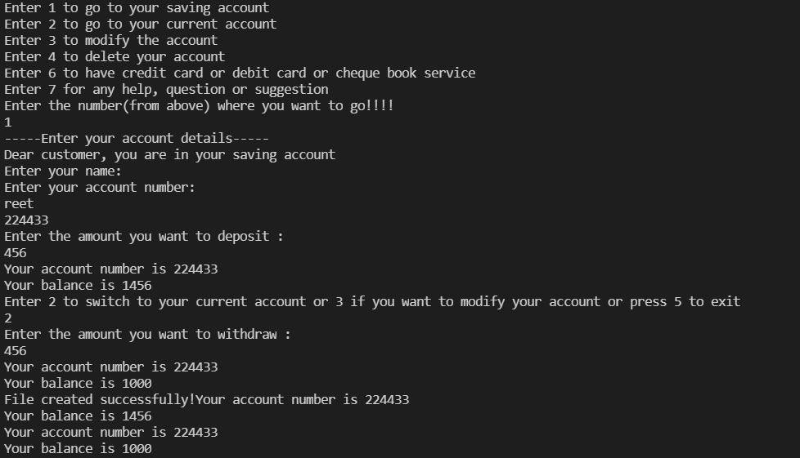

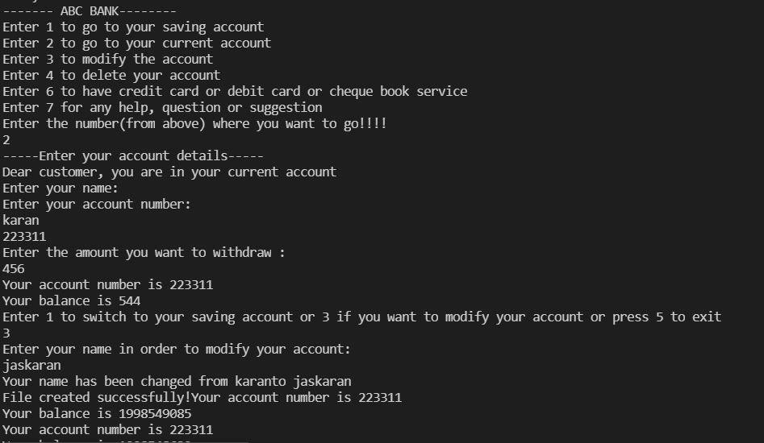

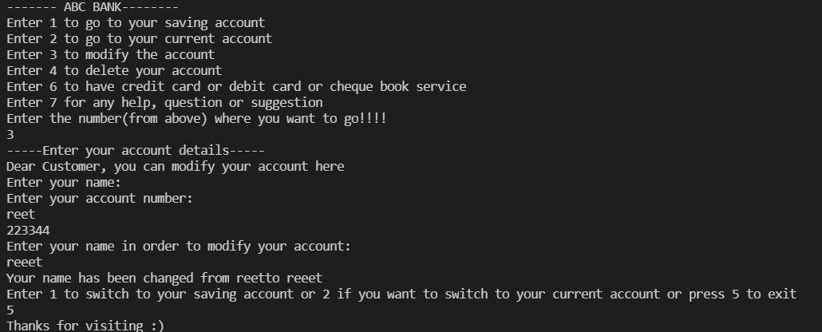

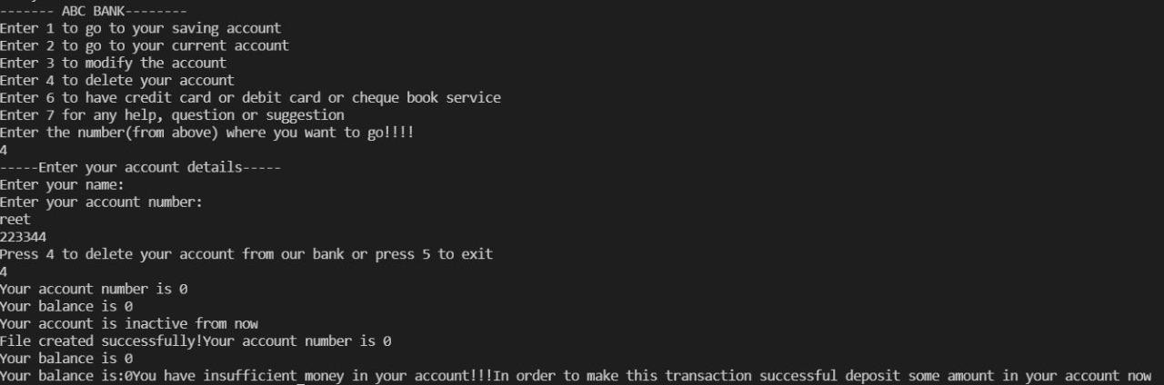



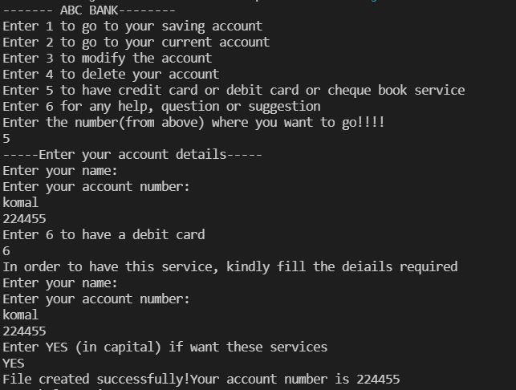

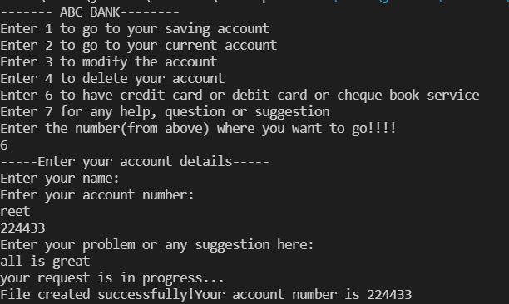

The above outputs show us that we can deposit money in our saving account, can withdraw money from our current account, can modify our existing account, can delete our account (if the customer wish to), can also avail the facility of having debit cards provided by the banks, and can also provide any suggestion for improvement to the bank and also can ask for help or guidance for a particular problem that he/she find themselves in.